In Brief | Mentoring Resources. Issue 3
This is the third in a series of Mentoring Resources which will provide you with links to material that may be of interest to you between mentoring sessions. We hope you find them useful!

The third Speaker Event in our 2017 Mentoring series was a fascinating discussion with Dr Marianne Broadbent, Managing Partner at NGS Global.

Marianne began her presentation by talking about her “blended life”. She began work as a high school teacher and has had many and varied roles since then, as well as raising four children and doing her Ph D. This required her to ‘brave up’ -Kathy Kaprino provides some hints for how to do this in this Forbes article.
 | Marianne emphasised the importance of challenging yourself in your career, advising us to go where we will learn, where we will grow, telling us that, great talent will go to where it is appreciated, valued, and encouraged to thrive. Marianne provided 10 Tips for Leading Yourself, including playing to your strengths, accepting responsibility for your development and not “doing guilt”.
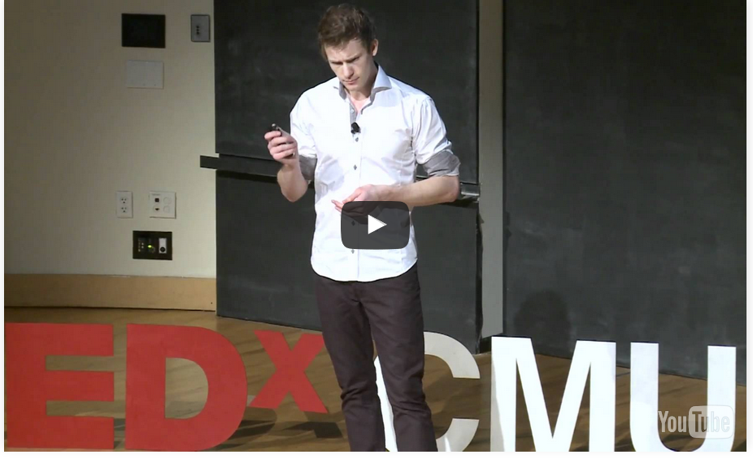 | Another tip from Marianne was that we should always remember that, in career terms, we are marketing ourselves and should be able to articulate our story. In this TED Talk, Jacob Cass shows us how to build our personal brand. Three more talks on marketing yourself can be found here.
 | Marianne described her work as an executive recruiter and the need for us as individuals to have diversity in our careers. Marianne also emphasised that successful career agility requires us to be able to learn and acquire new knowledge in our complex world. This post from Mentoring Works talks about career agility in the 21st century.
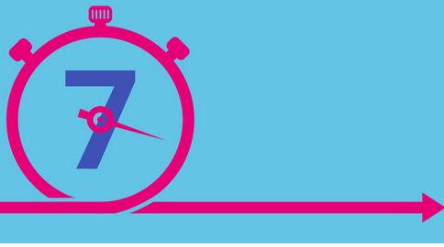 | In this article in Government News, Marianne says that when organisations are looking for talented individuals who can tackle problems differently, it is often hard to find them internally if most staff have never worked anywhere else. If you are going to move jobs, though, make sure that job change broadens or progresses your skills base. This post from seek.com.au suggest seven signs that it may be time to change jobs.

